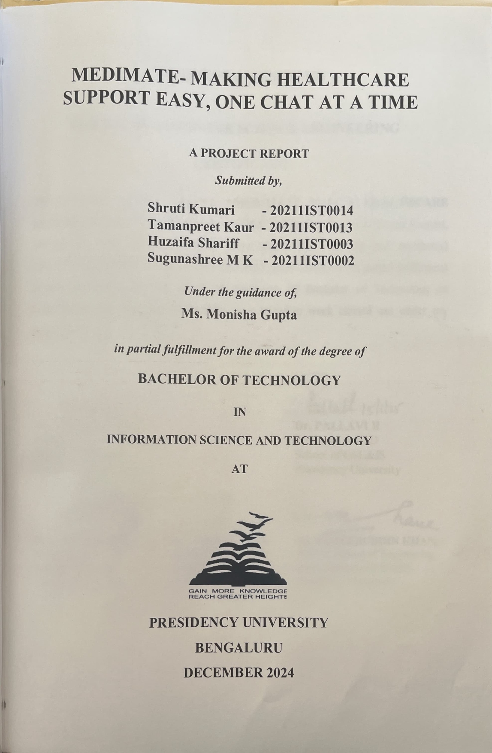

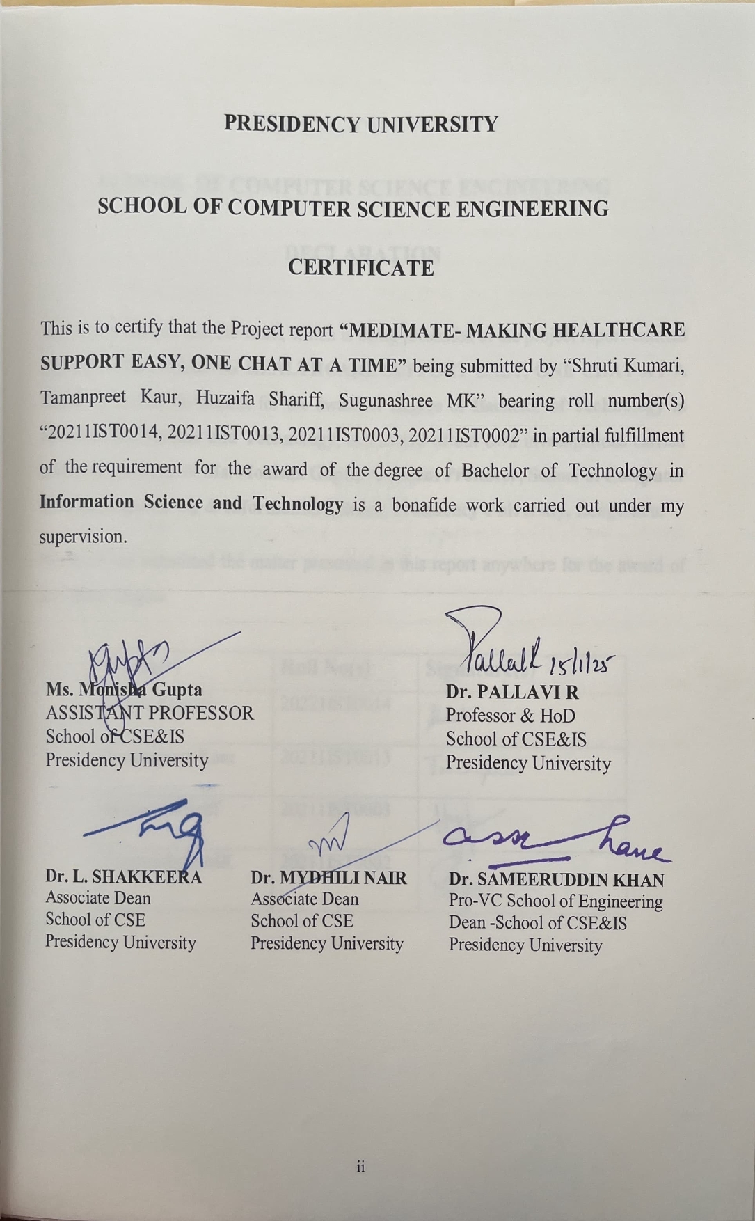

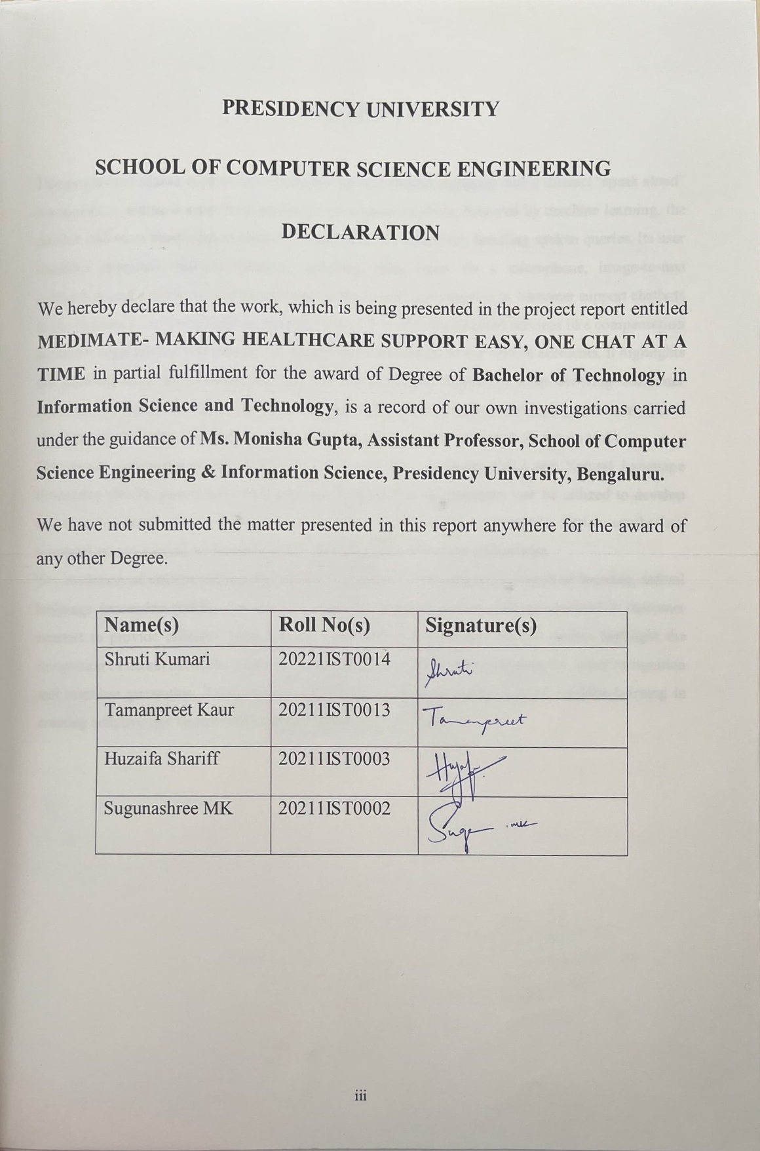

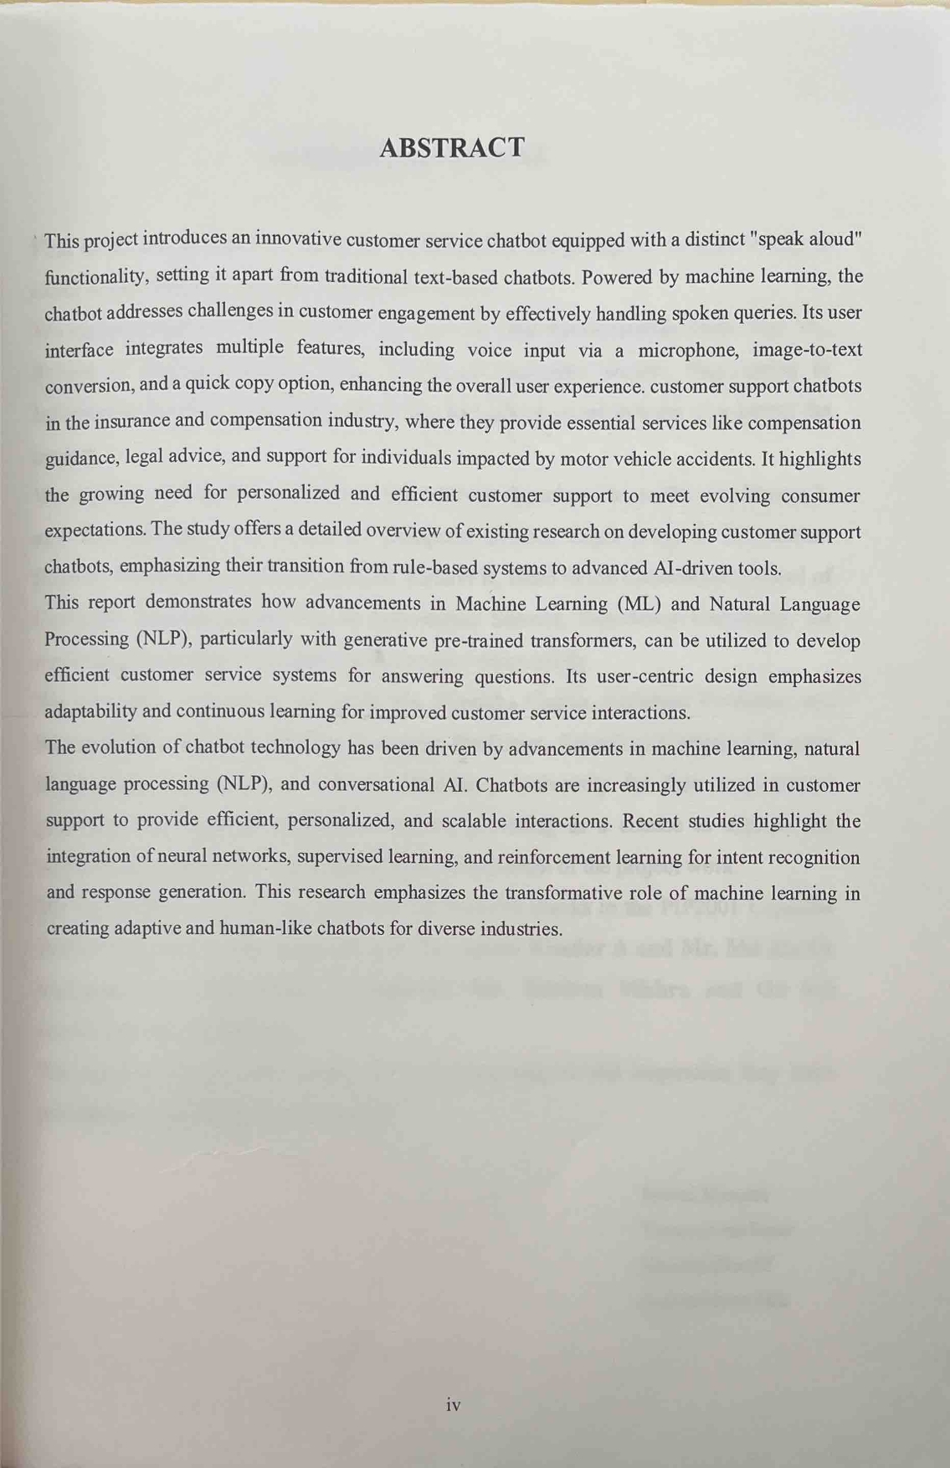

First of all, we indebted to the **GOD ALMIGHTY** for giving me an opportunity to excel in our efforts to complete this project on time.

We express our sincere thanks to our respected **Dr. Md. Sameeruddin Khan**, Pro- VC, School of Engineering and Dean, School of Computer Science Engineering & Information Science, Presidency University for getting us permission to undergo the project.

We express our heartfelt gratitude to our beloved Associate Deans **Dr. Shakkeera L and Dr. Mydhili Nair,** School of Computer Science Engineering & Information Science, Presidency University, and Dr. **Pallavi R**, Head of the Department, School of Computer Science Engineering & Information Science, Presidency University, for rendering timely help in completing this project successfully.

We are greatly indebted to our guide **Ms. Monisha Gupta, Assistant Professor** and Reviewer **Mr. Srinivas Mishra, Assistant Professor**, School of Computer Science Engineering & Information Science, Presidency University for their inspirational guidance, and valuable suggestions and for providing us a chance to express our technical capabilities in every respect for the completion of the project work.

We would like to convey our gratitude and heartfelt thanks to the PIP2001 Capstone Project Coordinators **Dr. Sampath A K, Dr. Abdul Khadar A and Mr. Md Zia Ur Rahman,** department Project Coordinators **Mr. Srinivas Mishra and** Git hub coordinator **Mr. Muthuraj.**

### We thank our family and friends for the strong support and inspiration they have provided us in bringing out this project.

**Shruti Kumari Tamanpreet Kaur Huzaifa Shariff Sugunashree MK**

|  |  |  |  |
| --- | --- | --- | --- |
| **Sl. No.** | **Table Name** | **Table Caption** | **Page No.** |
| 1  2 | Table 2.1  Table 7.1 | Major findings based on research paper  Gantt Chart | 15-16  29 |

|  |  |  |  |
| --- | --- | --- | --- |
| **Sl. No.** | **Figure Name** | **Caption** | **Page No.** |
| 1 | Figure 1.1 | General workflow of chatbot | 2 |
| 2  3  4  5  6  7  8  9  10  11  12  13  14 | Figure 1.2  Figure 1.3  Figure 1.4  Figure 4.1  Figure 4.2  Figure 7.1 Figure A2.1 Figure A2.2 Figure A2.3 Figure A2.4 Figure A2.5 Figure A2.6  Figure A3.1 | Evolution of Chatbots  Benefits of Customer Support Chatbot Healthcare Chatbot Features Lifecycle of Healthcare Chatbot Proposed idea/approach  Gantt Chart Registration Page Login Page Chatbox page Disease prediction  Appointment booking  Successful appointment booking message SDG | 3  5  7  21  23  29  42  43  43  44  44  45  50 |

|  |  |  |
| --- | --- | --- |
| **CHAPTER NO**  **1.**  **2.** | **TITLE**  **ABSTRACT ACKNOWLEDGMENT**  **INTRODUCTION**   * 1. Chatbot      1. Evolution of chatbots   2. Machine Learning      1. Role of Machine Learning in Chatbots   3. Significance in Customer Support   4. The need for Innovation   5. Problem Statement   6. Motivation      1. Improving Access and Availability      2. Enhancing Patient Engagement and Satisfaction      3. Reducing Administrative Burdens      4. Addressing Healthcare Accessibility Challenges   **LITERATURE SURVEY**   * 1. Introduction      1. Applications of Machine Learning-Based Chatbots Across Industries      2. Research Focus and Industry Applications of Chatbot Design      3. Development and Evaluation of Chatbot Prototypes      4. Knowledge-Based Chatbots and Enhanced User Experience      5. Knowledge Integration and Personalization in Chatbots      6. Challenges in   Knowledge Base Design and | **PAGE NO.**  **iv v**  **1**  1  2  3  3  5  5  7  8  9  9  10  10  **11**  11  11  11  12  12  12  13 |

|  |  |  |
| --- | --- | --- |
| **3.**  **4.**  **5.** | Maintenance for Chatbots   * + 1. Impact of Chatbots on Customer Service in the Financial Sector     2. Chatbots in Remote Service Delivery and Risk Management     3. Chatbots in Healthcare Insurance and Process Automation   **RESEARCH GAPS OF EXISTING METHODS**   * 1. Limited Contextual Understanding   2. Generalization Across Domains   3. Lack of Multilingual Proficiency   4. Inadequate Emotional Intelligence   5. Scalability and Performance Under Load   6. Data Privacy and Ethical Concerns   3.10 Bias and Fairness  **PROPOSED MOTHODOLOGY**   * 1. Define Objectives and Scope   2. Data Collection and Preparation   3. Model Selection and Training      1. Natural Language Processing (NLP)      2. Machine Learning Approaches   4. Integration with Platforms   5. Testing and Iteration   6. Deployment and Monitoring   **OBJECTIVES**   * 1. Enhancing Customer | 13  14  14  **17**  17  17  17  18  18  18  18  **19**  19  19  19  19  20  20  20  21  **22**  22 |

|  |  |  |
| --- | --- | --- |
| **6.**  **7.**  **8.**  **9.**  **10.** | Experience   * 1. Automation of Repetitive Tasks   2. Implementation of Machine Learning for Adaptability   3. User-Centric Design and Accessibility   4. Data Privacy and Security   5. Cost-Effectiveness and Operational Efficiency   **SYSTEM DESIGN AND IMPLEMENTATION**   * 1. System Architecture   2. Implementation of Existing Methods   3. Tools and Frameworks for Implementation   4. Challenges in System Design   **TIMELINE FOR EXECUTION OF PROJECT**  **OUTCOMES**  **RESULTS AND DISCUSSION**   * 1. Introduction      1. Registration Page      2. Login page      3. Chatbot interface      4. Appointment booking **CONCLUSION REFERENCES APPENDIX A APPENDIX B APPENDIX C**   **SDG** | 22  22  22  23  23  **24**  24  25  26  26  **27**  **28**  **29**  29  29  29  30  31  **32**  **34**  **36**  **40**  **45**  **49** |

# CHAPTER-1 INTRODUCTION

## Chatbot

Customer support Chatbots are now a crucial part of contemporary service sectors, providing users with individualised and effective support. These systems are essential for handling claims-related enquiries, providing legal advice, and providing general support, especially in fields like insurance and compensation. Chatbots enhanced with machine learning (ML) technology have become more popular among organisations due to the growing demand for scalable, round-the-clock customer service solutions.

Chatbots are specialised software programs created to mimic human-like speech or text exchanges. As virtual assistants, they streamline processes including information retrieval, recommendation-making, and query answering. Modern developments in machine learning (ML) and artificial intelligence (AI) have greatly improved chatbot capabilities, allowing them to communicate with people in a natural and flexible way.

Customer service is a key factor in evaluating a company's success in the fast-paced world of today. Companies are always looking for methods to reduce operating expenses and increase user happiness. Users may become frustrated by traditional customer support techniques, which can entail lengthy wait times and restricted availability. Technology-driven solutions, such as chatbots for customer service, have become increasingly popular as a means of addressing these issues. These chatbots seek to offer consumers quick, individualised, and effective assistance at any time of day by utilising developments in artificial intelligence and machine learning.

Through this project, we aim to explore the potential of integrating intelligent systems into customer service operations, ultimately contributing to increased efficiency and customer satisfaction. The project focusses on developing a machine learning-powered customer support chatbot that automates routine interactions and improves the overall customer experience. The chatbot uses Natural Language Processing (NLP) to understand and respond to customer enquiries effectively, mimicking human-like conversations. With the ability to handle a wide range of enquiries, from FAQs to troubleshooting assistance, this system not only reduces the workload of human agents but also ensures prompt and accurate support.

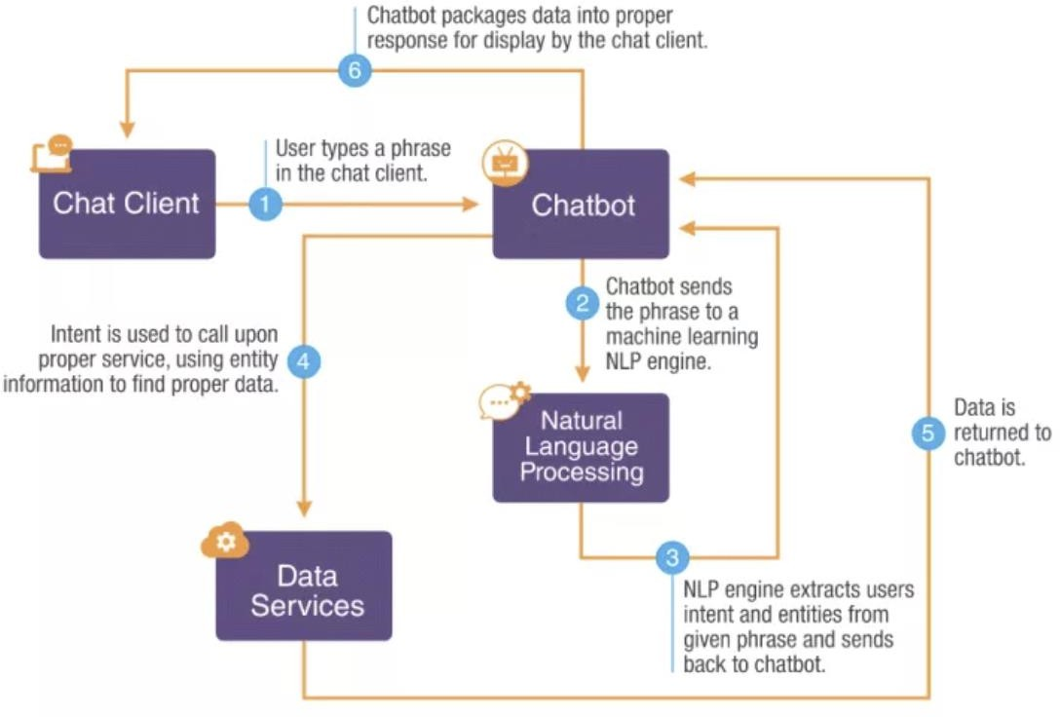

**Fig 1.1** General workflow of chatbot

#### Evolution of Chatbots

Initially, chatbots were rule-based, relying on predefined scripts and keyword matching to respond to specific inputs. While effective for basic tasks, these systems struggled with complex or unexpected queries. Over time, retrieval-based and self-learning chatbots emerged. Retrieval-based systems utilized datasets to identify patterns, whereas self-learning bots employed sophisticated algorithms, leveraging AI and ML to continuously improve their performance based on user interactions.

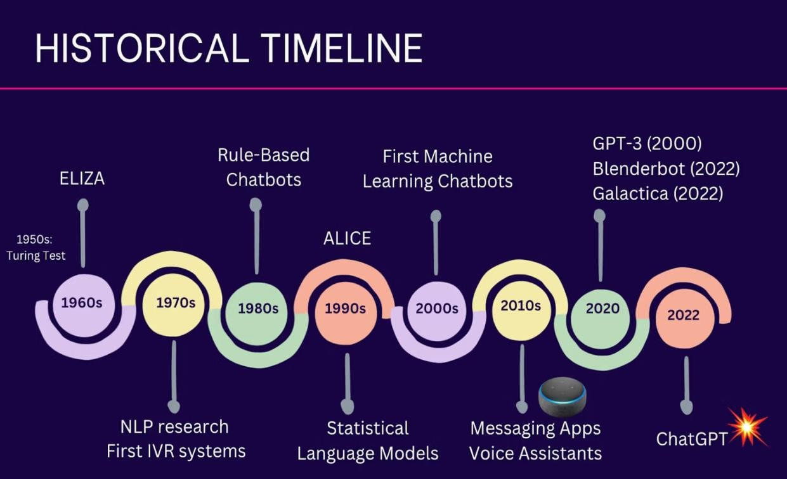

**Fig 1.2** Evolution of Chatbots

## Machine Learning

Machine learning allows chatbots to move beyond static, rule-based frameworks to advanced AI-driven systems capable of understanding complex queries and delivering tailored responses. These innovations are revolutionizing customer interactions, making support more accessible and efficient while reducing operational burdens on human agents.

#### Role of Machine Learning in Chatbots

Machine learning plays a pivotal role in the development of advanced chatbots. It allows systems to learn from vast datasets, enabling them to recognize user intent, generate context- aware responses, and adapt to new scenarios. Key ML techniques such as supervised, unsupervised, and reinforcement learning empower chatbots to evolve over time, making them more efficient and accurate.

Machine learning (ML) plays a crucial role in powering chatbots, making them intelligent and capable of improving over time. Here's how ML contributes to chatbots:

#### Natural Language Understanding (NLU):

ML helps chatbots understand user input by analyzing text, identifying intent, and extracting relevant information. For example, it enables the bot to recognize phrases like "I need help" or "What's the weather?”.

#### Context Awareness:

ML enables chatbots to maintain the context of a conversation, making interactions more natural. For instance, it allows a chatbot to remember previous questions or preferences during a chat session.

#### Personalization:

Machine learning helps chatbots tailor responses based on user behavior, preferences, or past interactions, creating a personalized experience.

#### Handling Complex Queries:

Advanced ML techniques like deep learning allow chatbots to handle more complex queries by analyzing vast amounts of data and recognizing patterns.

#### Speech-to-Text and Text-to-Speech:

ML is used for voice-based chatbots, enabling them to convert spoken words into text (speech-to-text) and respond with natural-sounding voices (text-to-speech).

#### Sentiment Analysis:

Chatbots can analyze the tone of the user's messages (e.g., happy, angry) and adjust their responses accordingly, enhancing customer satisfaction.

By leveraging machine learning, chatbots become smarter, more accurate, and better equipped to assist users in various domains, from customer support to education.

## Significance in Customer Support

Chatbots are transforming customer support by offering 24/7 availability, instant responses, and consistent service quality. Industries such as e-commerce, healthcare, and finance benefit from their ability to handle repetitive queries, workflows, and reduce operational costs.

Machine learning enhances this transformation, enabling chatbots to provide personalized assistance, understand diverse languages, and even interpret user sentiment.

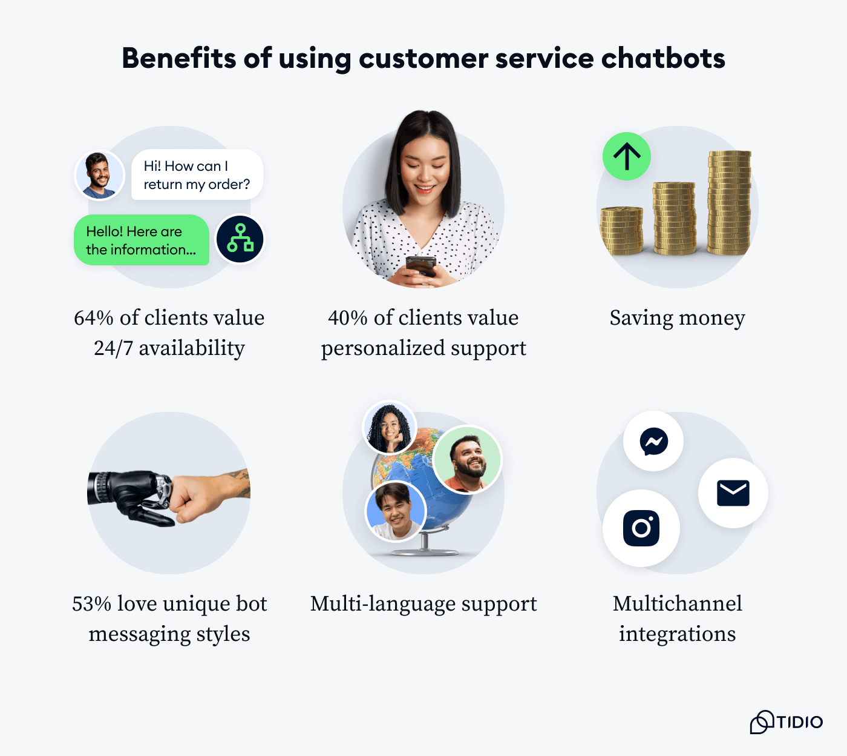

**Fig 1.3** Benefits of Customer Support Chatbot

## The need for Innovation

Despite their advancements, current chatbot systems face limitations, such as difficulty understanding ambiguous queries and ethical concerns related to data privacy. This project addresses these gaps by incorporating innovative features like voice interaction, image-to-text conversion, and continuous learning mechanisms, ensuring the chatbot remains adaptive and user-friendly.

The Need for Innovation stems from the constant demand for improvement and adaptation in a rapidly evolving world. Here’s why innovation is essential:

#### Solving New Problems:

As societies and industries evolve, new challenges arise. Innovation helps develop creative solutions to address these emerging issues.

#### Staying Competitive:

Businesses need to innovate to stay ahead of competitors, meet changing customer needs, and maintain relevance in the market.

#### Improving Efficiency:

Innovation leads to better processes, technologies, and tools that increase productivity and reduce costs.

#### Enhancing Quality of Life:

Innovative products and services, such as medical advancements or renewable energy, improve living standards and address global challenges.

#### Adapting to Change:

The world is constantly changing due to technological, environmental, and societal shifts. Innovation ensures we can adapt and thrive in this dynamic environment.

#### Driving Economic Growth:

New ideas and technologies create industries, generate jobs, and stimulate economic development.

#### Encouraging Sustainability:

Innovation is essential for developing eco-friendly solutions to tackle issues like climate change and resource scarcity.

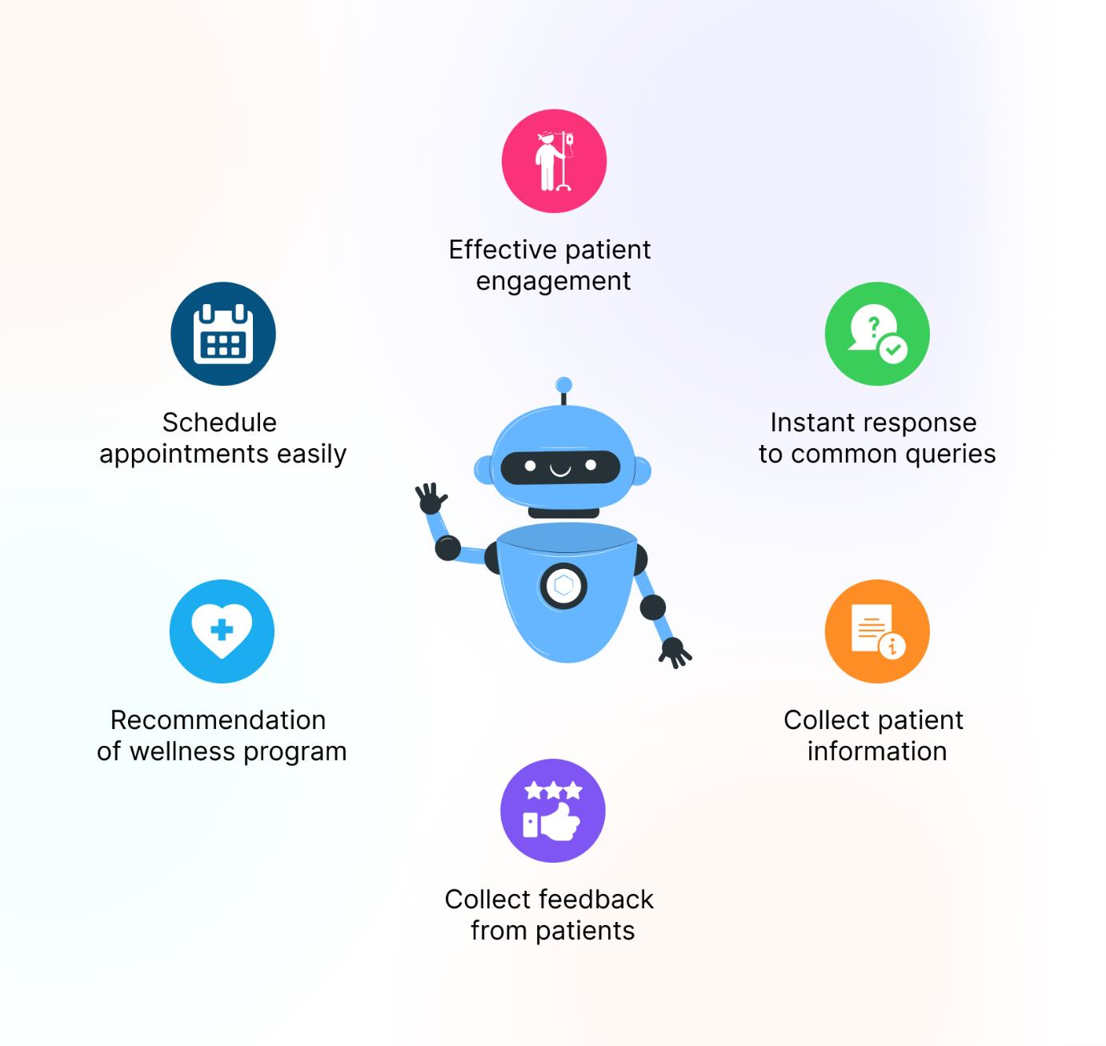

**Fig 1.4** Healthcare Chatbot Features

## Problem Statement

Traditional customer support systems often struggle with inefficiencies, such as long response times, limited availability outside business hours, and an inability to handle large volumes of queries simultaneously. These challenges lead to customer dissatisfaction and increased operational costs for businesses. The need for a scalable, efficient, and cost-effective solution is critical. This project aims to address these issues by developing a customer support chatbot powered by machine learning, capable of providing instant, accurate, and personalized responses, ensuring improved user experience and reduced dependency on human agents.

## Motivation

In the modern era, where customer satisfaction is a key driver of business success, providing efficient and reliable customer support is more critical than ever. However, traditional customer support systems are often plagued by limitations such as delayed responses, high operational costs, and challenges in handling large volumes of inquiries. These issues not only impact customer satisfaction but also strain company resources.

The rapid advancements in machine learning and artificial intelligence offer an opportunity to revolutionize customer service. By creating an intelligent chatbot, businesses can provide instant, accurate, and personalized support, available 24/7. This project is motivated by the potential to bridge the gap between customer expectations and the constraints of traditional support systems, enabling businesses to enhance their efficiency, reduce costs, and build stronger customer relationships through innovative technology.

The healthcare industry is one of the most critical sectors, responsible for providing essential services that directly impact the well-being of individuals. However, despite the continuous advancements in medical science and technology, healthcare systems around the world still face several challenges in terms of access, efficiency, and patient satisfaction. A key challenge is the pressure on healthcare providers to deliver timely, accurate, and personalized care, while simultaneously managing a growing patient population and increasing administrative burdens. Traditional methods of customer support, including call centers and in-person interactions, often struggle to meet these demands, resulting in longer wait times, patient frustration, and decreased satisfaction.

The increasing complexity of healthcare systems and the growing volume of patient inquiries have created a pressing need for innovative solutions that can enhance customer support. One promising approach is the integration of artificial intelligence (AI) and machine learning (ML) into customer service processes, particularly in the form of chatbots. Healthcare chatbots powered by ML algorithms have the potential to transform how patients interact with healthcare providers, enabling quicker, more accurate, and more personalized responses to patient inquiries.

#### Improving Access and Availability

In the healthcare sector, timely access to information and support is critical. Patients often have urgent questions regarding their medical conditions, treatment plans, insurance coverage, or appointment scheduling. In many cases, these questions are routine but time-consuming, requiring significant resources from human customer support agents. Long wait times and delayed responses can exacerbate patients' anxiety, particularly when they are dealing with complex health issues.

A customer support chatbot can provide immediate responses to these questions, 24/7. By leveraging natural language processing (NLP) and machine learning, the chatbot can understand the context of patient inquiries and deliver relevant, accurate information instantly. For instance, a patient may inquire about the availability of a particular specialist, or they may need to reschedule an appointment. A well-designed chatbot can handle these tasks autonomously, improving accessibility and reducing the burden on human agents. With ML, the chatbot continuously improves its ability to understand diverse patient queries and offer relevant solutions, which makes it highly efficient and scalable.

#### Enhancing Patient Engagement and Satisfaction

The success of any healthcare system is highly dependent on patient satisfaction. Healthcare providers must not only deliver high-quality medical care but also ensure that patients feel valued, heard, and understood. This involves establishing clear lines of communication between patients and healthcare providers, and maintaining regular engagement throughout a patient’s journey. While patient satisfaction can be influenced by the quality of medical treatment, it is also impacted by the quality of customer support.

A chatbot, equipped with machine learning, can be trained to personalize interactions based on the individual’s needs, preferences, and medical history. The chatbot can remember previous interactions, understand patient context, and offer relevant advice or follow-up information. For example, a chatbot can remind patients about upcoming appointments or medication schedules, answer post-care questions, and even assess a patient’s emotional state to escalate more sensitive cases to human agents if needed.

Personalized interactions foster a sense of connection and trust, leading to greater patient satisfaction. Furthermore, by providing instant access to health-related information and support, the chatbot reduces patients' frustrations with long wait times and enhances their overall experience with the healthcare system.

#### Reducing Administrative Burdens

Healthcare professionals often find themselves burdened by repetitive administrative tasks, which distract from their core responsibility—patient care. A significant portion of a healthcare professional’s time is spent on administrative duties such as answering routine inquiries, updating patient records, or managing appointment schedules. This not only reduces the efficiency of healthcare operations but also increases costs, as it requires additional staff or resources to handle these tasks.

A customer support chatbot, on the other hand, can efficiently handle a large volume of these routine administrative tasks. With machine learning algorithms, the chatbot can automatically schedule appointments, send reminders, answer common patient queries, and even triage patient concerns before escalating them to human agents. This allows healthcare professionals to focus on more complex and urgent matters, improving the overall efficiency of the healthcare system. Additionally, by automating these tasks, the chatbot reduces the chances of human error and ensures consistency in the quality of patient interactions.

#### Addressing Healthcare Accessibility Challenges

In many parts of the world, healthcare systems are overwhelmed, leading to challenges in accessibility and equity. Rural areas, underserved populations, and lower-income individuals may face difficulties in accessing healthcare services due to geographical, financial, or cultural barriers. These patients often have limited access to medical professionals or healthcare facilities, which can negatively impact their health outcomes.

A customer support chatbot powered by ML can bridge these gaps by providing patients in remote or underserved locations with access to critical health information and support without the need for in-person visits. With multilingual capabilities and access to accurate, evidence- based health information, chatbots can cater to diverse populations, regardless of their location or background. Additionally, chatbots can ensure that patients receive consistent care and attention, even when human healthcare providers are unavailable, thus mitigating the impact of geographic and socioeconomic disparities.

From improving accessibility and engagement to reducing administrative burdens and increasing patient satisfaction, chatbots have the potential to enhance the efficiency and effectiveness of healthcare systems. By enabling healthcare providers to deliver faster, more personalized, and data-driven support, these technologies will not only enhance the patient experience but also contribute to more efficient, sustainable, and equitable healthcare systems worldwide.

# CHAPTER-2 LITERATURE SURVEY

* 1. **Introduction**

"MediMate," our healthcare chatbot, addresses the gaps identified in prior research by combining advanced natural language processing with domain-specific knowledge to provide accurate, efficient, and user-friendly healthcare assistance, surpassing existing solutions in performance and contextual adaptability. It leverages machine learning to provide personalized healthcare advice and guidance, addressing the limitation of generic responses often seen in traditional chatbots. Unlike general-purpose chatbots, MediMate is specifically trained on healthcare data, enabling it to provide precise and context-aware responses tailored to medical inquiries. MediMate ensures compliance with healthcare data protection regulations, such as HIPAA, addressing concerns about the privacy and security of sensitive user information.

#### Applications of Machine Learning-Based Chatbots Across Industries

Chatbots that adopt a [machine learning approach](https://www.sciencedirect.com/topics/computer-science/machine-learning-approach) have been used in many different industries and applications, such as education ([Kerlyl et al., 2006](https://www.sciencedirect.com/science/article/pii/S1567422321000703?ref=pdf_download&fr=RR-2&rr=8d5d9fa519cb7ea3&b0135)), medical ([Laranjo et al., 2018](https://www.sciencedirect.com/science/article/pii/S1567422321000703?ref=pdf_download&fr=RR-2&rr=8d5d9fa519cb7ea3&b0155)), and government ([Androutsopoulou et al., 2019](https://www.sciencedirect.com/science/article/pii/S1567422321000703?ref=pdf_download&fr=RR-2&rr=8d5d9fa519cb7ea3&b0015)). Chatbots are frequently used to facilitate customer service experience, including but not limited to selling, promotion and customer engagement. ([Androutsopoulou et al., 2019](https://www.sciencedirect.com/science/article/pii/S1567422321000703?ref=pdf_download&fr=RR-2&rr=8d5d9fa519cb7ea3&b0015), [Cui et al., 2017](https://www.sciencedirect.com/science/article/pii/S1567422321000703?ref=pdf_download&fr=RR-2&rr=8d5d9fa519cb7ea3&b0080)). MediMate leverages a machine learning-driven approach to transform the healthcare experience by providing accurate, personalized, and engaging patient support, bridging the gap in customer service quality within the medical industry.

#### Research Focus and Industry Applications of Chatbot Design

All the studies aim at presenting the chatbot design or architecture that addresses the identified research problems, gaps, or questions. The chatbots serve customers in different industry sectors, including tourism (Acharya et al., 2020), e-commerce (Bhawiyuga et al., 2017), and telecommunication (Paikens et al., 2020). The motivations of the studies usually come from

the limited research on the desired chatbots (Bhawiyuga et al., 2017; Luo and Tong, 2019; Paikens et al., 2020; Wang et al., 2019; Schanke et al., 2021) or the existing approaches that cannot do well at some specific situation or address some specific problems (Chakrabarti and Luger, 2012; Chakrabarti and Luger, 2015).

#### Development and Evaluation of Chatbot Prototypes

In most of the studies, system prototypes were developed (Acharya et al., 2020; Chakrabarti and Luger, 2015; Paikens et al., 2020), some of which were evaluated through user survey, expert review, or experiments. Almost all the evaluation results for the system prototypes reported that the proposed chatbots performed well and effectively. They could improve the performance, accuracy, or efficiency of the operations. MediMate builds on this foundation by incorporating user-centered design principles and real-world testing, ensuring high performance, accuracy, and efficiency in healthcare operations while continually adapting to user needs and feedback for optimal effectiveness.

#### Knowledge-Based Chatbots and Enhanced User Experience

The chatbots could improve the end-to-end user experience because it is more convenient for customers to acquire information during online shopping (Cui et al., 2017), thereby helping save time and human effort (Paikens et al., 2020). Some studies present the conceptual design without developing a prototype or conducting any evaluation, such as (Kurachi et al. 2018). A KB contains the required knowledge and information to support artificial conversation, such as product information, frequently asked questions (FAQs), dialog history, historical behaviors, and facts. The conversational agents will retrieve the required information or knowledge from the KB to understand customers’ queries and construct answers to the questions. MediMate addresses this issue by utilizing an extensive healthcare knowledge base that includes medical FAQs, symptom data, and user interaction history, enabling accurate and context-aware responses that save time, reduce human effort, and provide a seamless healthcare assistance experience.

#### Knowledge Integration and Personalization in Chatbots

From the literature, a number of chatbots are supported by KB containing FAQs and data crawled from external sources, such as webpages (Herrera 2019).There are also some chatbots that answer queries incorporating chat history (Griol Molina 2016; Wang 2019) or user

profiles and behaviors (Cha 2019).

By using a thorough and up-to-date knowledge base enhanced with behavioral insights, medical FAQs, and interaction history, MediMate overcomes these constraints. With this method, the chatbot can offer context-aware, individualized healthcare assistance that changes over time to meet the needs of the user. MediMate guarantees that every encounter is significant and pertinent by incorporating user-specific data, including medical history, preferences, and behavioral patterns. This not only improves the user experience but also fosters dependability and confidence, which makes MediMate a more useful tool for providing healthcare solutions that are customized to meet the needs of each individual. MediMate shows how chatbots may provide intelligent, flexible, and customized interactions by going beyond static responses with this sophisticated integration.

#### Challenges in Knowledge Base Design and Maintenance for Chatbots

Researchers found that the chatbot with a KB and dialog history can generate more informative responses (Wang et al. 2019).However, all of them only discuss the KB briefly, without any deeper investigation into it. Moreover, the designs of the KBs in those studies are not underpinned by any theoretical basis. On the other hand, to maintain the quality of the information and knowledge supporting effective conversations between the conversational agent and customers, the KB must be updated. However, based on the literature of KB- supported chatbot, this issue was overlooked. MediMate addresses this issue by employing a theoretically grounded and dynamically updated knowledge base, ensuring the accuracy and relevance of information for effective healthcare conversations, while leveraging automated processes to keep the knowledge base current and reliable.

#### Impact of Chatbots on Customer Service in the Financial Sector

Text-based chatbots are used in various financial sectors, such as banking, insurance and ecommerce services, to improve the existing quality of customer service, user satisfaction, human productivity and workload, etc. Suhel et al. (2020) revealed that implementing chatbots in banking and financial sectors can increase the quality of user service, productivity and proportion of satisfied users, as well as reduce human workload. MediMate solves this issue in the healthcare sector by enhancing service quality, user satisfaction, and operational efficiency, while reducing the workload on medical professionals by providing timely, accurate, and personalized healthcare information through intelligent chatbot interactions.

#### Chatbots in Remote Service Delivery and Risk Management

Illescas-Manzano et al. (2021) reported that implementing chatbots can help clients living in remote areas receive proper service and bring modernity, efficiency and intimacy. Gondaliya et al. (2020) studied the various factors influencing risks, including the type of service and its pricing plans, infrastructure, quality level and number of users prior to chatbot implementation. MediMate addresses this issue by providing accessible and personalized healthcare assistance to users in remote areas, improving service efficiency, while mitigating risks through careful integration of service quality, user feedback, and reliable medical data.

#### Chatbots in Healthcare Insurance and Process Automation

Nayak et al. (2021) showed that health insurers are pursuing new technological opportunities to improve innovative products, backed by a strong knowledge base. Chatbots can help with process automation, decision-making, information gathering vendor integration, performance monitoring, resource management, contracting and administration. MediMate addresses this issue by streamlining healthcare processes such as decision-making, resource management, and patient engagement, supported by a robust knowledge base, thus enhancing efficiency, reducing administrative workload, and improving service delivery in healthcare settings.

**Table 2.1** Major findings based on Research Paper

|  |  |  |  |  |  |
| --- | --- | --- | --- | --- | --- |
| **Sl.**  **No.** | **Author** | **Challenges/ Research Problems** | **Objectives** | **Methodology** | **Major Findings** |
| 1. | Bhawiyuga et al. (2017) | The research work on designing chatbots aimed at e-commerce is still very limited. | Propose the design and implementation of an e-commerce chatbot system that provides automatic responses to customers’ questions. | System development, experiment | In the usability and performance testing, the proposed system can automatically deliver the answer in less than 5 s with relatively good matching accuracy |
| 2. | Cui et al. (2017) | There are significant issues in terms of data scale and privacy. | Present a customer service chatbot that leverages large- scale and publicly available commerce data. | System development | Improved the end- to-end user experience in terms of online shopping as it is more convenient for customer’s  information acquisition. |
| 3. | Doherty and Curran (2019) | There is a lack of technology in place to enhance the customer online banking  experience. | Implement a web- based chatbot to assist with online banking. | System development, experiment | Enhance accessibility. |
| 4. | Herrera et al. (2019) | Help people interact more easily | Present a live  customer service using a chatbot along with several  services. | System development | Customer support and experience are improved. |
| 5. | Kurachi et al. (2018) | Improve efficiency of contact centers by utilizing AI. | Outline the contact point solution and describe the AI chatbot technology behind the solution | Concept presentation only | It proposes the CHORDSHIP  Digital Agent, which is equipped with an AI technology ideal for contact centers; it is a “conversation- machine learning  hybrid AI” |
| 6. | Suhel et al. (2020) | Limited number of tests considered in the study. | Ontology-based dialog handling in the area of banking and finance. | Case studies | Implementation of chatbots can enhance the quality of user services and reduce human  workload. |

|  |  |  |  |  |  |
| --- | --- | --- | --- | --- | --- |
| 7. | IllescasManza no et al. (2021) | Chatbot application deployment platform privacy restriction. | Leads generated approach | Survey | Chatbot implementation leads to immediate response customer  query |
| 8. | Nuruzzaman and Hussain (2020) | Existing chatbots  have several shortcomings, e.g. failing to provide a meaningful response to the user, offering semantically incorrect information etc. | Proposes a domain- specific chatbot, that uses multiple strategies to generate a response. | System development, experiment | The comparison results between it and 3 other chatbot demonstrate its  superiority in providing the user with a complete answer and engaging them in a  dialogue. |
| 9. | Chakrabarti and Luger (2014) | Contemporary chatter bots do not perform well at tasks where a specific context has to be maintained across a several utterance  exchanges pairs. | Demonstrate a modular, robust, and scalable architecture for chatter bots. | System development, experiment | The proposed  system had a success rate of 87.5%. |
| 10. | Putri et al. (2019) | There is only little research in  developing chatbot- hotel in Indonesia. | Develop an interactive intelligent personalized chatbot-hotel by using AIML and Google Flutter. | System development | The proposed prototype chatbot- hotel Berscha in Indonesia was developed; however, no performance evaluation was  reported. |

# CHAPTER-3

**RESEARCH GAPS OF EXISTING METHODS**

While significant progress has been made in the development and deployment of customer support chatbots, several research gaps remain in current methodologies. Below is an analysis of the existing research gaps based on the provided papers:

## Limited Contextual Understanding

Understanding and remembering context over lengthy discussions is a major difficulty for many chatbots. Although contextual comprehension has been somewhat enhanced by advances in natural language processing (NLP), especially with transformer-based models like BERT and GPT, many chatbot implementations still struggle to handle multi-turn dialogues. This constraint is particularly noticeable in situations that call for prolonged and cohesive interactions, like technical assistance or customer service, when several levels of context must be understood and referred to during the discussion. The chatbot's incapacity to retain context affects its capacity to provide insightful and contextually aware responses, frequently leading to generic or repetitious responses that irritate users. Future chatbot systems must use more sophisticated conversational modeling and stronger memory methods to get around these restrictions.

## Generalization Across Domains

Existing chatbots are often domain-specific and struggle to generalize knowledge across different industries or contexts. This is due to the reliance on domain-specific training data and models that are not designed to adapt dynamically to new areas. The absence of robust transfer learning frameworks for chatbots limits their applicability in diverse settings.

## Lack of Multilingual Proficiency

Most chatbots are primarily optimized for English or a limited number of commonly spoken languages, however others support many languages. This poses a serious obstacle to accessibility for users who speak low-resource or uncommon languages. The difficulty of maintaining consistency across languages and the lack of high-quality linguistic data are two issues that current multilingual training approaches frequently fail to address. Because of this, chatbots usually function poorly in a variety of language contexts, which causes misunderstandings and makes them difficult for non-native English speakers to use.

## Inadequate Emotional Intelligence

Chatbots often fail to recognize and respond to user emotions, which is crucial for customer support. While sentiment analysis is integrated into some systems, they lack the deeper emotional intelligence needed to handle sensitive conversations effectively. Incorporating emotional context into chatbot responses remains a critical gap.

## Scalability and Performance Under Load

As user demand increases, many chatbots exhibit performance degradation, such as slower response times or reduced accuracy. Current methods do not adequately address scalability issues, particularly for systems handling high query volumes in real-time.

## Data Privacy and Ethical Concerns

Chatbots handling sensitive customer data face challenges in ensuring compliance with privacy regulations like GDPR. Many existing systems lack robust mechanisms to anonymize and secure data, raising ethical and legal concerns. Further, biases in training data can lead to discriminatory or inappropriate responses, which are under-addressed in current research.

## Bias and Fairness

AI-driven chatbots frequently inherit biases present in their training data, which can lead to unfair or biased interactions. Techniques for identifying and mitigating bias in chatbot systems are still in their infancy, posing a significant risk to equitable customer support.

# CHAPTER-4 PROPOSED MOTHODOLOGY

The development of a customer support chatbot leveraging machine learning follows a systematic and iterative process. The methodology combines technical architecture, machine learning models, and user-centric design to create an efficient, scalable, and personalized chatbot system. Below is a detailed breakdown:

## Define Objectives and Scope

The initial phase involves defining the chatbot’s goals, such as addressing customer inquiries, automating repetitive tasks, and improving user satisfaction. Specific use cases are outlined, such as handling frequently asked questions, providing real-time support, or integrating into customer relationship management (CRM) systems. This step ensures alignment with organizational needs and user expectations.

## Data Collection and Preparation

A dataset of customer interactions, such as email logs, chat transcripts, or call center dialogues, is collected. For machine learning-based chatbots, this data is preprocessed to clean, tokenize, and standardize it. Tools like Python’s NLTK or spaCy can be used for preprocessing tasks, including removing stop words, stemming, and lemmatization. The labeled dataset is divided into training, validation, and test sets to develop and evaluate the model.

## Model Selection and Training

#### Natural Language Processing (NLP)

NLP techniques form the backbone of the chatbot:

* + - * Intent Recognition: Models like BERT or DistilBERT can classify user intents, such as “complaint,” “product inquiry,” or “account help”.
      * Entity Recognition: NLP systems identify critical information, such as dates, product names, or order IDs.

#### Machine Learning Approaches

* + - * Supervised Learning: For labeled data, supervised learning algorithms like decision trees, support vector machines (SVMs), or neural networks can predict responses.
      * Unsupervised Learning: Clustering methods, such as k-means, identify patterns in unlabeled data to group similar customer queries.

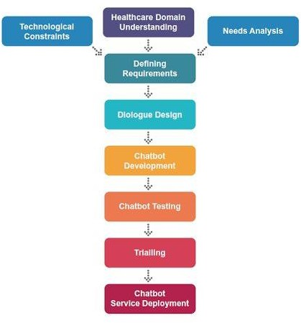

**Fig 4.1** Lifecycle of Healthcare Chatbot

## Integration with Platforms

The chatbot is integrated with messaging platforms like Facebook Messenger, WhatsApp, or websites through APIs. Platforms like Dialogflow, Rasa, or Microsoft Bot Framework are often used for streamlined deployment.

## Testing and Iteration

Extensive testing ensures the chatbot handles diverse scenarios:

* Functional Testing: Ensures all chatbot functionalities work as expected.
* Performance Testing: Evaluates speed and accuracy under load conditions.
* User Testing: Collects feedback from end-users to refine conversational flows.

## Deployment and Monitoring

The chatbot is deployed in the live environment with robust monitoring mechanisms to track performance, identify bottlenecks, and handle user feedback. Metrics like response time, accuracy, and customer satisfaction are used to measure success.

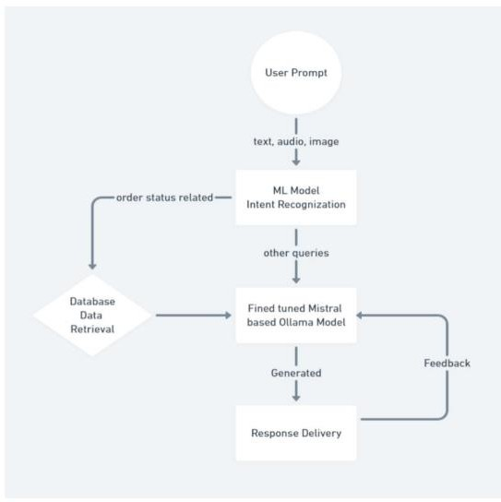

**Fig 4.2** Proposed idea/approach

By following this methodology, the chatbot not only automates customer interactions but also provides a personalized and seamless user experience, fostering trust and satisfaction. This systematic approach ensures scalability, adaptability, and long-term success for customer support systems.

# CHAPTER-5 OBJECTIVES

Based on the insights from the provided research papers, the objectives of a customer support chatbot project leveraging machine learning can be structured as follows:

## Enhancing Customer Experience

The primary goal of the chatbot is to provide seamless and efficient customer service by addressing customer queries in real time. By leveraging advanced Natural Language Processing (NLP) techniques, the chatbot aims to deliver accurate, context-aware, and personalized responses, reducing response times and improving customer satisfaction. This aligns with findings on the integration of chatbots into CRM systems to enhance customer relationships.

## Automation of Repetitive Tasks

One of the key objectives is to automate repetitive and routine tasks, such as answering frequently asked questions or handling simple inquiries. This reduces the workload on human agents, allowing them to focus on more complex issues. Rule-based and retrieval-based chatbots play a significant role in this area, as they can handle predefined scenarios efficiently.

## Implementation of Machine Learning for Adaptability

The project aims to incorporate machine learning algorithms, such as supervised and reinforcement learning, to enable the chatbot to learn and adapt over time. By analyzing user interactions, the chatbot can improve its ability to predict intents, understand complex queries, and deliver more accurate responses. This objective is supported by the growing application of sequence-to-sequence models and neural networks in chatbot development.

## User-Centric Design and Accessibility

A critical objective is to design an intuitive and user-friendly interface that caters to users of varying technical proficiencies. Features like customizable UI, voice-to-text capabilities, and proactive assistance enhance usability and engagement.

## Data Privacy and Security

Given the sensitive nature of customer interactions, the chatbot must prioritize data privacy and security. Implementing secure protocols for data transmission and storage is essential to build trust and comply with regulatory requirements.

## Cost-Effectiveness and Operational Efficiency

Finally, the project seeks to deliver a cost-effective solution for businesses by reducing dependency on human agents and optimizing efficiency. Automating routine queries can significantly lower costs while maintaining high service quality. This comprehensive set of objectives ensures that the chatbot meets immediate customer support needs and aligns with long-term goals of adaptability, scalability, and continuous improvement in service delivery.

# CHAPTER-6

**SYSTEM DESIGN & IMPLEMENTATION**

The design and implementation of customer support chatbots involve several critical stages, combining artificial intelligence, natural language processing (NLP), and system integration strategies. Below is a detailed overview of existing methods for system design and implementation, based on insights from the referenced research papers.

## System Architecture

The system architecture of customer support chatbots typically follows a modular approach, with the following key components:

#### User Interface (UI)

* + The front-end interface, accessible via websites, mobile apps, or messaging platforms like WhatsApp, Facebook Messenger, or Slack, enables seamless interaction between users and the chatbot. Modern designs focus on text and voice inputs.

#### Natural Language Processing (NLP) Engine

* + The core of a chatbot system, the NLP engine, processes user input to extract intents and entities. Pre-trained models like BERT, GPT, or spaCy often form the backbone of the NLP engine.

#### Intent Recognition and Dialogue Management

* + Intent recognition models classify user input into predefined intents using supervised learning algorithms like decision trees, SVM, or deep learning architectures like transformers.
  + Dialogue management ensures that the chatbot maintains conversational context and determines the next response. Rule-based methods are used for this purpose

#### Knowledge Base and Retrieval System

* + The knowledge base stores predefined answers, FAQs, or dynamic data (e.g., product details, account information).
  + Retrieval-based systems match user queries to the most relevant responses using cosine similarity, TF-IDF, or semantic search techniques.

#### Backend Integration

* + Integration with databases, CRMs, or APIs enables the chatbot to fetch dynamic information, such as order statuses or personalized recommendations.

#### Feedback and Learning Modules

* + Feedback loops allow the chatbot to improve over time by incorporating user corrections or analyzing failed interactions. Reinforcement learning or continuous retraining on new datasets is implemented for iterative improvement.

## Implementation of Existing Methods

#### Rule-Based Chatbots

* + Rule-based systems are designed with predefined rules and workflows to handle structured queries. These systems rely on decision trees or regular expressions, making them simple to implement but limited in flexibility
  + Example: A customer support chatbot for handling FAQs using keyword matching or trigger-based responses.

#### Retrieval-Based Chatbots

* + Retrieval-based systems use similarity measures to match user queries to predefined responses stored in the knowledge base. These chatbots do not generate new responses, limiting adaptability.

#### Generative Chatbots

* + Generative chatbots use sequence-to-sequence models, such as recurrent neural networks (RNNs), Long Short-Term Memory (LSTM) networks, or transformer-based architectures like GPT. Requires large-scale datasets of conversational transcripts, such as OpenSubtitles or customer service logs.

#### Hybrid Chatbots

* + Combining rule-based and AI-driven approaches, hybrid chatbots leverage the simplicity of rule-based systems with the adaptability of machine learning.
  + Example: Rule-based workflows for structured queries and generative models for open-ended queries.

## Tools and Frameworks for Implementation

* + - Dialogflow: Provides a cloud-based framework for NLP, intent recognition, and platform integration.
    - Microsoft Bot Framework: Facilitates multi-channel deployment and integration with enterprise systems.
    - Hugging face: Leading AI company providing open-source tools,libraries,and pre trained models for natural language processing (NLP) tasks, such as its popular Transformers library.
    - TensorFlow and PyTorch: Used for developing and training custom machine learning

models for NLP tasks .

## Challenges in System Design

* Handling Ambiguity: Managing uncertain or ambiguous user inputs effectively.
* Scalability: Ensuring the system performs well under high user loads.
* Multilingual Support: Adapting to diverse languages and dialects.
* Data Privacy: Ensuring compliance with regulations like GDPR while handling sensitive customer data.

# CHAPTER-7

**TIMELINE FOR EXECUTION OF PROJECT (GANTT CHART)**

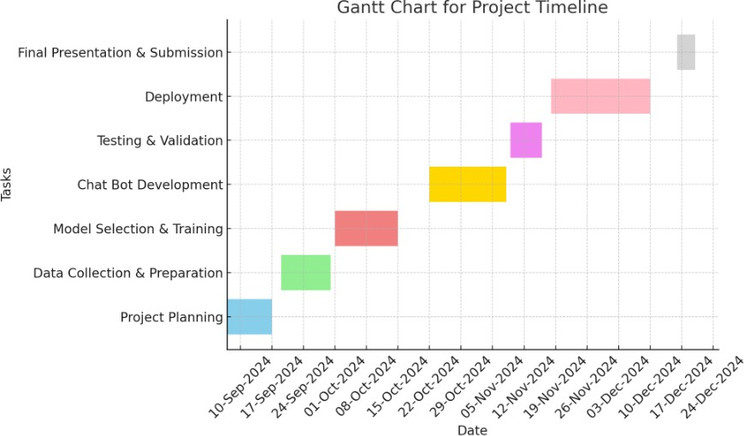

**Fig 7.1** Gantt Chart

The Gantt chart illustrates the timeline for executing the project by dividing it into distinct tasks, including project planning, data collection and preparation, model selection and training, chatbot development, testing, deployment, and final submission. Each task is represented by a horizontal bar, showing its duration and sequence on a timeline that spans from 10-Sep-2024 to 24-Dec-2024. The X-axis indicates the dates, while the Y-axis lists the tasks in sequential order, providing a clear breakdown of the project's structure and schedule.

# CHAPTER-8 OUTCOMES

* **Enhanced Customer Experience**: The chatbot will handle a large volume of queries efficiently, providing real-time responses, and improving customer satisfaction.
* **Increased Efficiency**: By automating common support requests, it will reduce the burden on human agents, allowing them to focus on complex issues.
* **Scalable Support**: The chatbot can scale to handle an increasing number of users simultaneously without the need for additional resources.
* **Continuous Learning**: The chatbot will adapt and improve over time through machine learning, enhancing its ability to provide accurate and relevant responses.
* **Improved Knowledge Base**: The chatbot will help build and update a dynamic knowledge base by learning from interactions and updating solutions for future use.
* **24/7 Availability**: The chatbot will offer uninterrupted customer service, available at any time to assist customers with their queries.
* **Personalized Responses**: Through NLP, the chatbot will deliver more personalized and contextual responses, improving customer satisfaction.
* **Data-Driven Insights**: The system will generate data from user interactions, helping the organization analyze trends and improve service quality.
* **Cost Reduction**: By automating support tasks, companies can reduce operational costs associated with human customer service agents.
* **Positive Customer Experience:** With faster, accurate, and personalized service, the chatbot enhances overall customer satisfaction and loyalty, contributing to the success of the organization.
* **Personalized Interactions:** By leveraging user data and machine learning, the chatbot can provide tailored responses, improving customer satisfaction and engagement.
* **Reduced Human Effort:** By addressing routine inquiries, the chatbot allows human agents to focus on more complex and high-priority issues.

# CHAPTER-9 RESULTS AND DISCUSSIONS

## Introduction

The **MediMate** project delivers an AI-powered chatbot designed for healthcare support. It provides symptom-based health assessments, reliable medical information, and saves chat history for up to a week. Built with Python, Flask, and JSON, it ensures a user-friendly experience, bridging the gap between users and healthcare providers with quick and accessible preliminary medical guidance.

#### Registration Page

The **Registration Page** for the MediMate project. It allows new users to create an account and access the chatbot's features. The form requires users to input their **Name**, **Date of birth, Phone Number**, **Email Address**, and **Password**.

* + - * The **Password field** includes an eye icon, enabling users to toggle the visibility of the entered password for convenience and accuracy.
      * A **Register button** is prominently displayed in purple, signaling the action to submit the form and create the account.
      * Below the form, there is a link labeled "Login here", providing existing users with an easy way to navigate to the login page.

The design is clean, user-friendly, and ensures essential fields are captured for secure and personalized interactions with the chatbot.

#### Login page

The **Login Page** for the **MediMate** project, designed to authenticate existing users and grant access to the chatbot's functionalities. The interface includes two primary fields:

* + - * **Email Field**: Users must enter their registered email address.
      * **Password Field**: Requires users to input their secure password. This field is masked to ensure privacy during entry.

Below the login button, a prompt guides users who do not have an account, directing them to the **Register here** link, which redirects to the registration page.

#### Chatbot interface

When the user accesses the page, they are greeted with a professional and user-friendly healthcare chatbot interface. They can type in symptoms, and the chatbot responds with potential disease predictions, offering detailed information like precautions, medications, and recommended doctors. The user can then book an appointment through a convenient form, and the page dynamically updates to confirm the appointment details.

**Key Features Displayed:**

* **Chatbox Section:**
* **Chatbox Area (.chatbox):**
  + This is a scrollable area where the chatbot's responses will be shown.
  + The chatbox has a background image (bot.jpg), which you can customize by changing the image URL.

#### User Input Section:

* **Input Field:**
  + The user can type their symptoms in an input field (#userInput), which is a simple text box with padding and a border. It appears under the chatbox.
  + This input field allows the user to describe their symptoms (e.g., fever, cough) to receive a disease prediction.
  + Below the input field is a button labeled "Get Prediction." When clicked, it triggers the getResponse() function to process the symptoms and predict a potential disease.

#### Response Section:

* **Disease Prediction:**
  + Once the user types their symptoms and clicks "Get Prediction," the chatbot processes the input and searches for diseases in a predefined list (diseases[]).
  + If matching symptoms are found, the chatbot displays a response with the predicted disease, precautions, medications, recommended diet, and suggested doctors.
  + If no matching symptoms are found, the chatbot will inform the user that it could not find any matching diseases and will suggest further consultation with a doctor.

#### Appointment booking

When the user successfully books an appointment, a confirmation message appears displaying "Appointment Booked Successfully!" along with the user's name, selected date, and time. The appointment details are presented in a clear and organized format with bold labels for each piece of information. The form is hidden after submission to keep the page neat, and the background image remains subtly visible behind the confirmation message, creating a seamless and professional appearance. The user can then either interact with the chatbot again or proceed as desired.

It provides structured information related to the condition:

* **Appointment Confirmation Message**: Displays a clear confirmation message stating "Appointment Booked Successfully!"

#### Details Shown:

* + **User's Name**: Displayed in bold.
  + **Date**: The chosen appointment date is shown in bold.
  + **Time**: The selected time is also displayed in bold.
* **Form Disappearance**: The appointment form automatically disappears after submission, keeping the interface clean and focused.

The confirmation is presented in a well-organized and easy-to-read format, maintaining consistency with the rest of the page's aesthetic. After booking the appointment, the user can continue interacting with the chatbot or explore other options on the page. The process feels seamless, intuitive, and professional, ensuring the user understands that their appointment is confirmed.

# CHAPTER-10 CONCLUSION

In conclusion, our machine learning (ML)-based customer service chatbot presents a transformative solution to enhancing customer relationships by addressing key challenges in traditional support systems. To bridge the research gap identified in prior studies, we proposed an innovative knowledge base (KB) design that integrates essential customer knowledge for value cocreation, alongside a system framework that allows continuous improvement. A case study with a leading international women’s intimate apparel manufacturer validated the effectiveness of the proposed system. The evaluation results revealed significant reductions in customer response times and human effort while maintaining 100% accuracy in comparison with human agents. These findings demonstrate the chatbot’s potential to streamline customer query handling and strengthen customer relationship management. Our machine learning- powered chatbot for customer service introduces a groundbreaking method to handle customer queries. By combining Language Model (LM) techniques with machine learning models, the system ensures flexibility and precision in understanding diverse user inputs. Enhanced features, such as multi-modal input methods (speech and image), quick copy capabilities, and an all-auto login mechanism, provide a secure, user-friendly, and efficient interface. Future improvements may focus on refining the accuracy of ML models, expanding language support, and adding new functionalities. This project paves the way for a new era in customer service, where advanced technology revolutionizes user experiences.

The integration of machine learning in customer support chatbots offers a transformative

approach to enhancing customer service. By automating routine tasks and delivering instant, accurate, and personalized responses, these chatbots significantly improve efficiency and customer satisfaction. The ability to operate 24/7, handle high query volumes, and continuously learn from interactions makes them a valuable asset for modern businesses. Furthermore, their scalability and integration with legacy systems, such as inventory management and CRM tools, provide a competitive edge by streamlining operations and reducing costs. As technology advances, the potential for these systems to evolve further— through expanded language support, voice integration, and improved models—ensures their relevance and effectiveness in addressing customer needs. Ultimately, machine learning- powered chatbots are paving the way for a new era of intelligent, efficient, and customer- focused support systems.

Meta Health customer chatbot serves as a valuable tool for enhancing customer support in the healthcare sector. By providing quick, accurate, and personalized responses, it improves user experience, reduces response times, and ensures consistent service availability. It can handle routine inquiries, appointment scheduling, and general health information efficiently, freeing up human agents to focus on more complex cases. Proper training, regular updates, and compliance with data privacy regulations are essential for maximizing its effectiveness and maintaining customer trust. Meta Health customer chatbot is designed to streamline healthcare communication by offering automated, real-time assistance to users.

Future work can expand on this research in several directions. Conducting additional case studies across diverse industries could offer a more comprehensive understanding of the system’s adaptability and scalability. Incorporating text-to-voice technology could further explore voice-based conversational agents, particularly in languages with limited research like Chinese. Moreover, integrating the chatbot with legacy systems, such as inventory management, could enhance its utility by providing real-time insights into stock availability, reducing manual errors, and supporting omnichannel strategies.

# REFERENCES

[1].Prof.K. Bala, Mukesh Kumar, Sayali Hulawale and SahiI Pandita, "Chat-Bot For College Management System Using A.I", International Research Journal of Engineering and Technology (IRJET), vol. 04, no. 11, pp. 2030-2033, Nov 2017.

[2].Guruswami Hiremath, Aishwarya Hajare, Priyanka Bhosale, Rasika Nanaware and K.

S. Wagh, "Chatbot for education system", International Journal of Advance Research Ideas and Innovations in Technology (IJARIIT), vol. 4, no. 3, pp. 37-43, 2018.

[3].K. Jwala, G.N.V.G Sirisha and G.V. Padma Raju, "Developing a Chatbot using Machine Learning", International Journal of Recent Technology and Engineering (IJRTE), vol. 8, no. 1S3, pp. 89-92, June 2019.

[4].Naeun Lee, Kirak Kim and Taeseon Yoon, "Implementation of Robot Journalism by Programming Custombot using Tokenization and Custom Tagging", International Conference on Advanced Communications Technology (ICACT), pp. 566-570, Feb 2017.

[5].Setiaji Bayu and Wibowo Ferry, "Chatbot Using a Knowledge in Database: Human-to- Machine Conversation Modeling", 7th International Conference on Intelligent Systems Modelling and Simulation (ISMS), pp. 72-77, Jan 2016.

[6].M. Nuruzzaman and O. K. Hussain, "A survey on chatbot implementation in customer service industry through deep neural networks", 2018 IEEE 15th International Conference on e-Business Engineering (ICEBE), pp. 54-61, 2018.

[7].A. Rahman, A. Al Mamun and A. Islam, "Programming challenges of chatbot: Current and future prospective", 2017 IEEE Region 10 Humanitarian Technology Conference (R10-HTC), pp. 75-78, 2017.

[8].J. Hill, W. Ford and I. Farreras, Real conversations with artificial intelligence: A comparison between human-human online conversations and human-chatbot conversations, vol. 49, 2015.

[9].I. Sutskever, Oriol Vinyals and Quoc V. Le, "Sequence to sequence learning with neural networks", Advances in Neural Information Processing Systems 27:Annual Conference on Neural Information Processing Systems 2014, pp. 3104-3112, December 8-13 2014.

[10].M. Adam, M. Wessel, A. Benlian, Ai-based chatbots in customer service and their effects on user compliance, Electron. Mark. (2020), pp. 1-19

[11].Abbas, A. (2022). Meta-Analysis in Machine Learning: Exploring Chatbot Applications.

# APPENDIX-A PSUEDOCODE

Here is a simplified pseudo-code to outline the structure and workflow for the **MediMate** project. It includes key functionalities like symptom assessment, medical information retrieval, and user interaction.

**registration.html**

START

DISPLAY "Registration Form" on the webpage

DEFINE a form with fields:

* Name (text input)
* Date of Birth (date input)
* Phone Number (tel input)
* Email (email input)
* Password (password input)
* Submit button

WHEN the user submits the form:

PREVENT the default form submission behavior

READ values from form inputs:

* + name
  + dob
  + phone
  + email
  + password

VALIDATE the inputs:

* + CHECK if ‘name’ contains only alphabets and spaces
  + CHECK if ‘email’ is in a valid email format
  + CHECK if ‘phone’ is a valid 10-digit number
  + CHECK if ‘password’ has at least:
    - 6 characters
    - One uppercase letter
    - One lowercase letter
    - One number

IF any validation fails:

DISPLAY corresponding error message on the webpage TERMINATE further execution

IF all validations pass:

STORE ‘email’ and ‘password’ in localStorage DISPLAY success message “Registration successful!” REDIRECT to “login.html” page

END

This pseudo code describes the logical flow of the registration process, including form input validation, error handling, data storage, and redirection.

**login.html**

START

DISPLAY “Login Form” with inputs:

* Email (text input)
* Password (password input)
* Login button

ON page load:

RETRIEVE saved email and password from localStorage (if available) AUTO-FILL email and password fields with saved values (if they exist)

WHEN the user submits the form:

PREVENT the default form submission behavior

READ values from:

* email field
* password field

IF both email and password are entered: DISPLAY success message “Login successful!” REDIRECT user to “chatbot.html”

ELSE:

DISPLAY error message “Please enter valid email and password.”

END

**chatbot.json**

START

DISPLAY chatbot interface with:

* Header: "Welcome to MediMate - Your Healthcare Chatbot"
* Chatbox for displaying responses
* Text input field for symptoms
* "Get Prediction" button

DEFINE a list of diseases with:

* Symptoms
* Precautions
* Medications
* Diet recommendations
* Suggested doctors

ON "Get Prediction" button click:

* READ user input (symptoms)
* MATCH symptoms against disease list
* IF match found:

DISPLAY predicted disease details in chatbox:

* + Disease name
  + Precautions
  + Medication
  + Diet
  + Suggested doctors

DISPLAY "Book Appointment" button

* ELSE:

DISPLAY "No matching disease found. Provide more details or consult a doctor."

ON "Book Appointment" button click:

* SHOW appointment form with:
  + Name field
  + Date picker
  + Time picker
  + "Book Appointment" button

ON appointment form submission:

* PREVENT default form submission
* READ name, date, and time
* DISPLAY confirmation with appointment details:
  + Name
  + Date
  + Time
* HIDE appointment form

END

This pseudo code provides a simplified logical flow of how the chatbot interacts with users to predict diseases, provide information, and manage appointment booking.

# APPENDIX-B SCREENSHOTS

### Navigate to the registration page

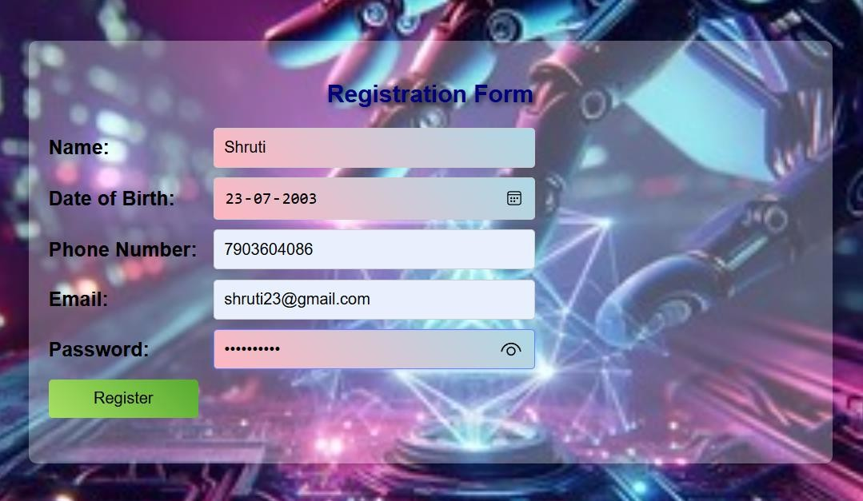

**Fig A2.1** Registration Page

### After navigation user is directed to the Login page

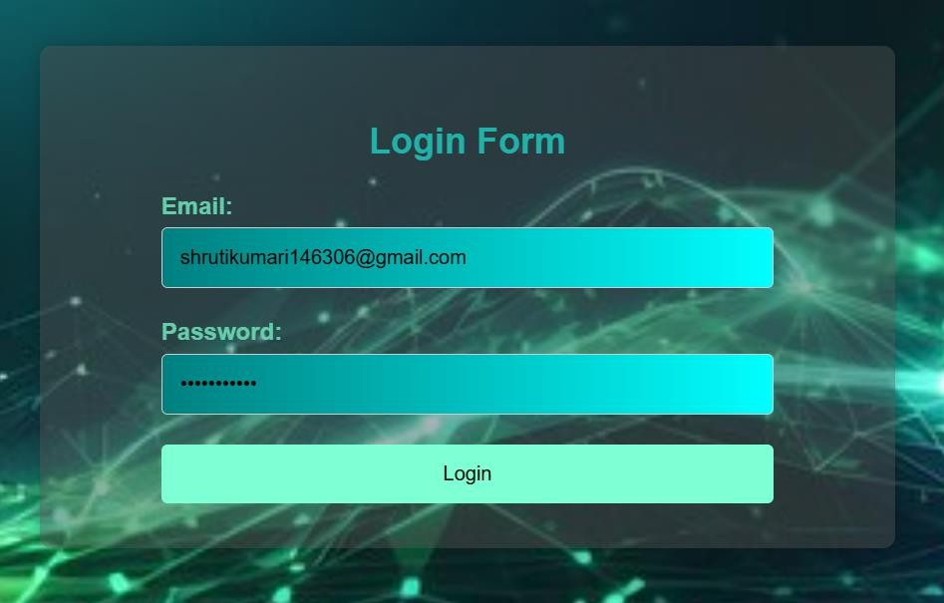

**Fig A2.2** Login Page

### After successfully getting logged in the user is directed to the chatbox page of the Medimate Healthacare Chatbot where the user can chat with the chatbot and get disease predictictions

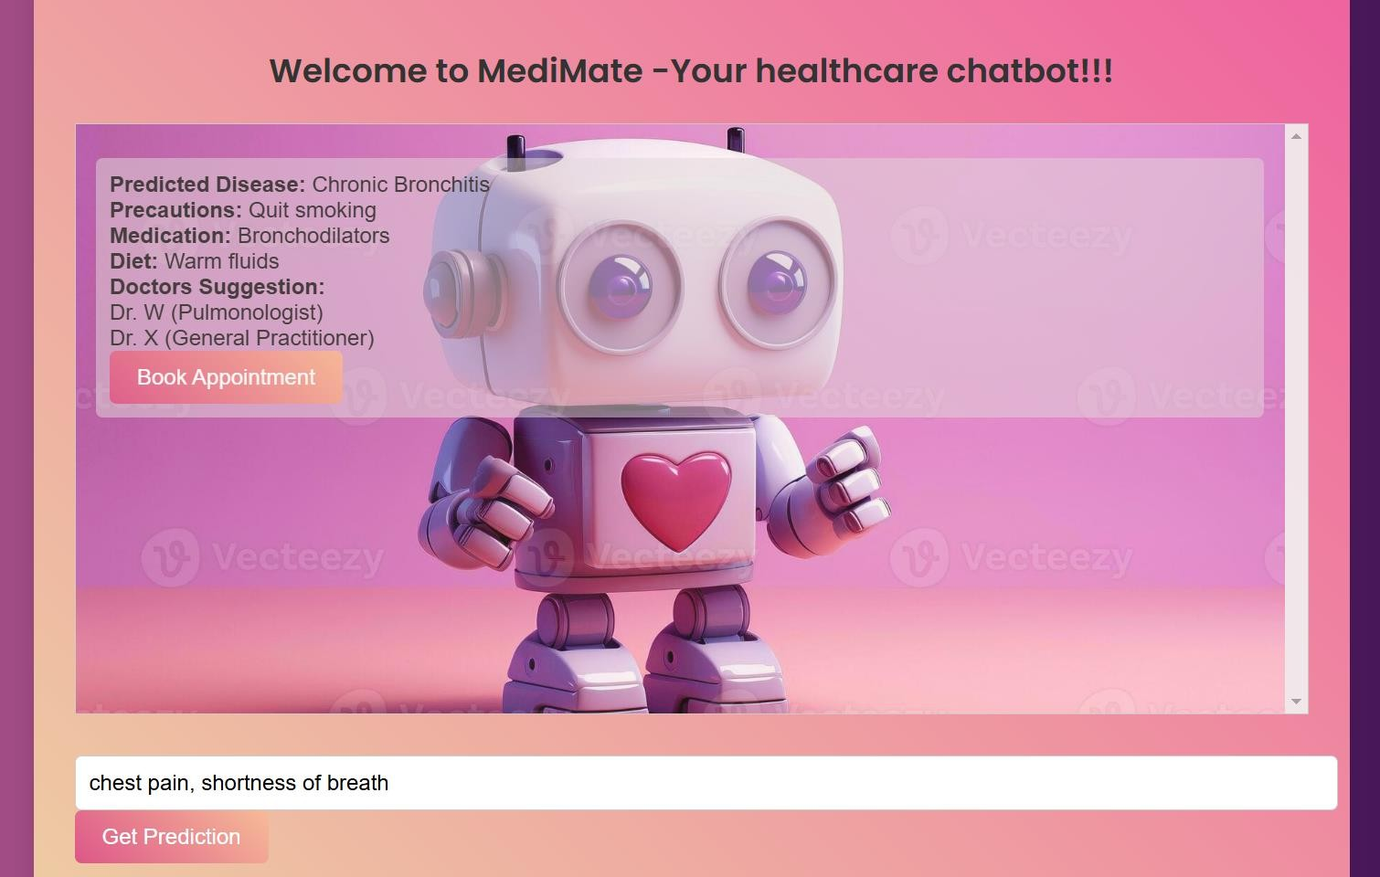

**Fig A2.3** Chatbox page

### After giving some symptoms as input the user gets disease prediction and an option to book appointment with a doctor

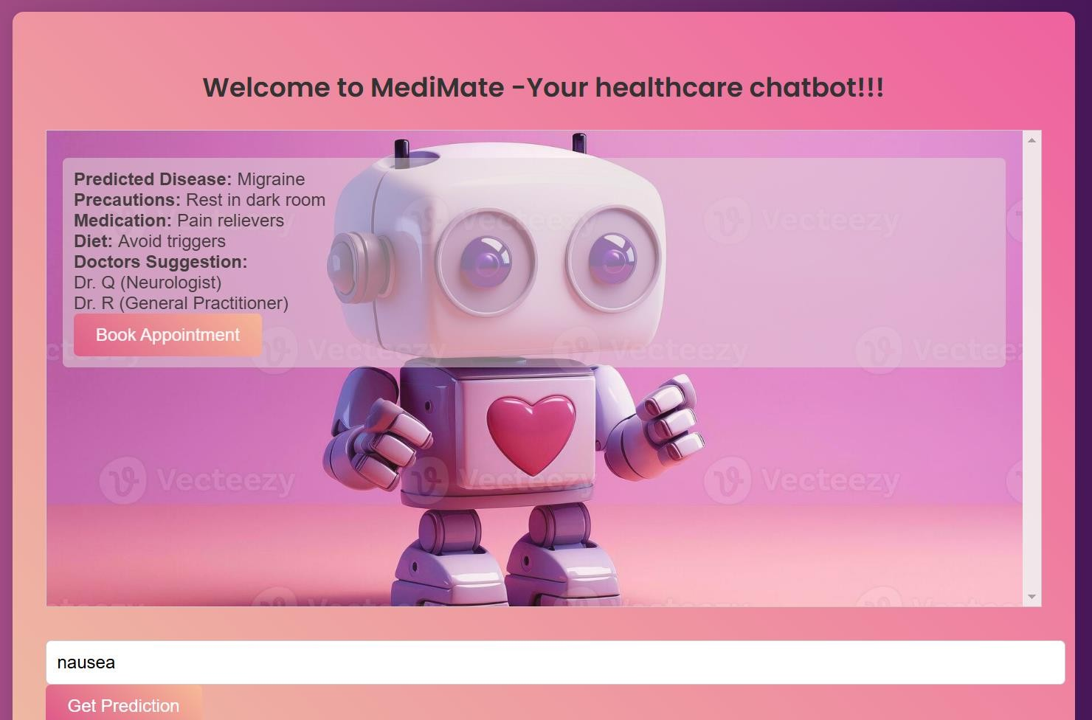

**Fig A2.4** Disease prediction

### After that the user is navigated to appointment booking section

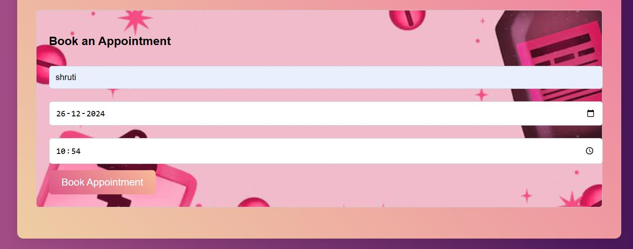

**Fig A2.5** Appointment booking

### After filling the details a successful appointment booking message is displayed



**Fig A2.6** Successful appointment booking message

# APPENDIX-C ENCLOSURES

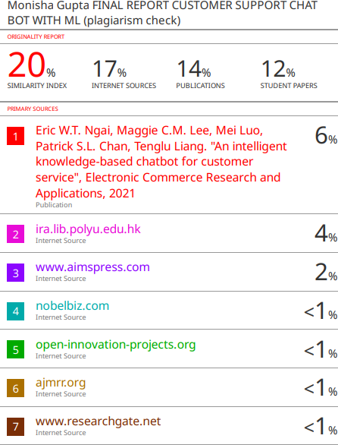

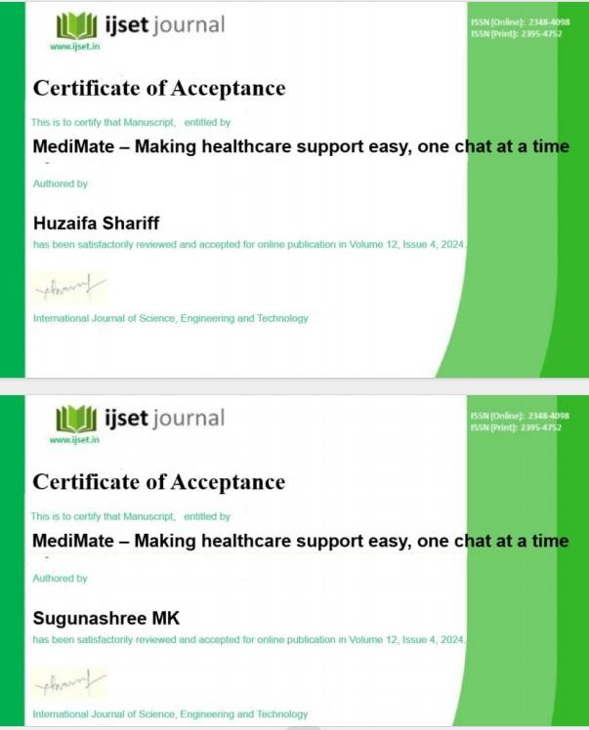

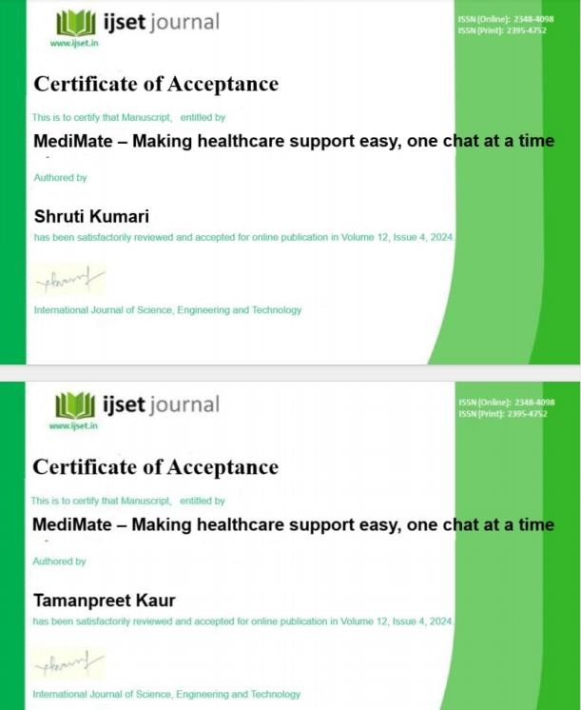

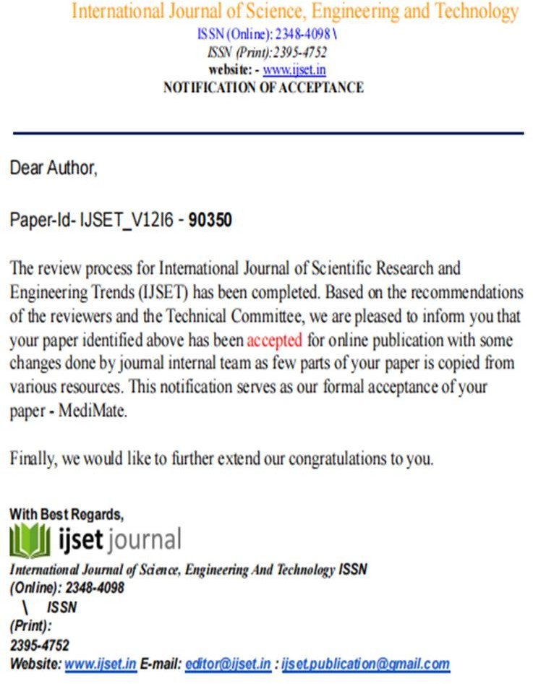

**SUSTAINABLE DEVELOPMENT GOALS (SDG)**

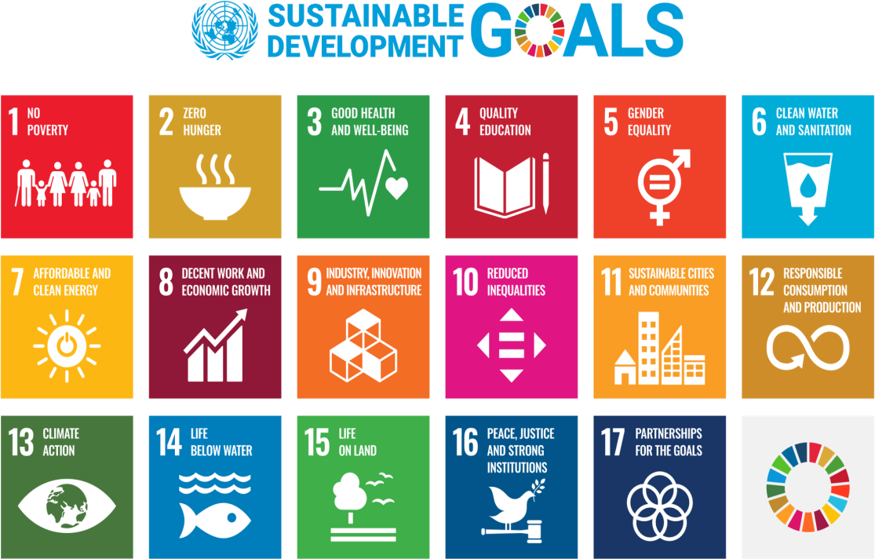

**Fig A3.1** SDG

The “MediMate” chatbot aligns with three key United Nations Sustainable Development Goals (SDGs): SDG 3 (Good Health and Well-being), SDG 9 (Industry, Innovation, and Infrastructure), and SDG 17 (Partnerships for the Goals).

#### SDG 3: Good Health and Well-being

MediMate addresses health challenges by providing personalized health advice, symptom analysis, and appointment scheduling. It improves access to healthcare, particularly in underprivileged areas, ensuring healthier lives and promoting well-being for all.

#### SDG 9: Industry, Innovation, and Infrastructure

MediMate leverages cutting-edge technologies such as AI, natural language processing (NLP), and scalable backend systems, contributing to the development of sustainable infrastructure and fostering innovation in healthcare.

#### SDG 17: Partnerships for the Goals

MediMate emphasizes collaboration between technology and healthcare sectors to create innovative solutions for global health challenges.